**Rates and Equilibrium Revision**



Grand-Pa, a fully South African brand, enjoys high awareness as a pain killer and is a household name. The brand offers consumers powders and tablets in a wide range of sizes to suit their personal needs and has a heritage of trust and proven performance owing to its potent triple action formulation which combines paracetamol, aspirin and caffeine. This has endeared it to millions of South Africans over the years making it South Africa's leading analgesics brand.

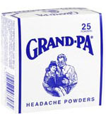

The following information appears on the package insert:

**GRAND-PA HEADACHE Tablets & GRAND-PA HEADACHE Powders.**

**COMPOSITION:**

Grand-Pa Headache Tablets:

Each **tablet** contains:

|  |  |
| --- | --- |
| Aspirin | 226,8mg |
| Paracetamol | 162,0mg |
| Caffeine | 32,4mg |

Grand-Pa Headache Powders:

Each **powder** contains

|  |  |
| --- | --- |
| Aspirin | 453,6mg |
| Paracetamol | 324,0mg |
| Caffeine | 64,8mg |

1.1 Taking the information above into consideration, how many Grand-Pa Tablets would

have the same effect as one Grand-Pa Powder. Explain. (2)

1.2 Claire has a terrible headache. You tell her that Grand-Pa *powders* would provide

faster relief to her headache than Grand-Pa *tablets*. Use the molecular collision theory

to explain why Grand-Pa powders would provide faster relief for her headache, than the

tablets would. (3)

1.3 Claire doesn’t take your advice. She thinks swallowing tablets is much easier and

more pleasant than swallowing powders. She also reasons that Grand-Pa tablets

are just Grand-Pa powders in compressed form, thus they should have the same

effect in the same amount of time.

You decide to prove your point to Claire by doing an investigation, using zinc and

excess hydrochloric acid to show how **surface area** affects the rate of a reaction:

**Zn(s) + HC**ℓ**(aq) → ZnC**ℓ**2(aq) + H2(g)**

**The following pieces of equipment should be used in your investigation:**

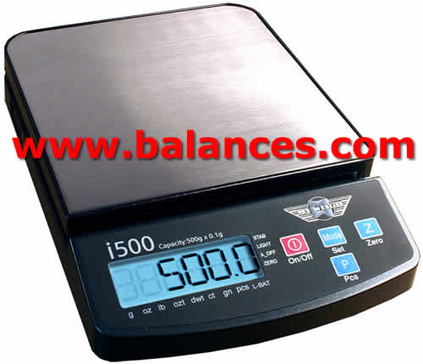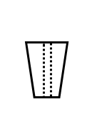

One holed **stopper**

**Mass meter**

500cm3 **conical flask** (markings on side record volume in graduations of 50cm3)

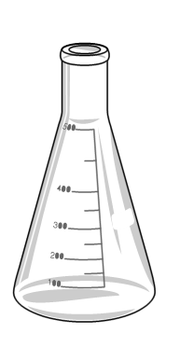

Beaker of **HCℓ**

**Gas syringe**

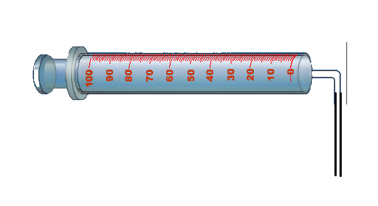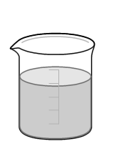

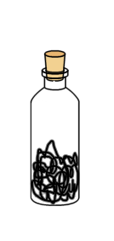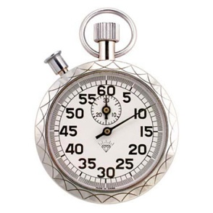

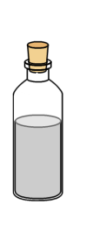

**Bottle containing zinc granules**

**Stop watch**

**Bottle containing zinc powder**

Design an experiment, using some of the above pieces of equipment that

would assist in explaining to Claire that surface area affects the rate of a reaction.

1.3.1 Draw a labelled diagram showing how you will set up the apparatus. 2)

1.3.2 Identify the **dependent variable**. (1)

1.3.3 Write a simple step by step method using numbered points. (4)

1.4 On one set of axes, draw two rough qualitative sketch graphs showing the volume

of gas collected against time for your investigation. (4)

1.5 Which variables should be kept constant (controlled) during this experiment? (3)

Read the following package insert:

**KNOWN SYMPTOMS OF OVERDOSAGE AND PARTICULARS OF ITS TREATMENT:**

**Aspirin:** These include dizziness, tinnitus, sweating, nausea, vomiting, mental confusion, hyperventilation, respiratory alkalosis, metabolic acidosis, ketosis and depression of the central nervous system. In children serious signs of overdosage may develop rapidly.  
  
**Paracetamol:** Liver damage which may be fatal may only appear after a few days. Symptonms of overdosage include nausea and vomiting. Acute intoxication causes kidney failure.  
  
**Caffeine:** Large doses may cause restlessness, excitement and muscle tremor.

In the event of overdosage consult a doctor or take the patient to the nearest hospital immediately. Specialised treatment is essential as soon as possible.  
The latest information regarding the treatment of over-dosage can be obtained from the nearest poison centre.

1.6 Would you advise a coffee addict to take Grand-Pa Powders? Explain. (2)

**[21]**

**Question 2**

Fritz Haber and Karl Bosch of Germany developed the Haber-Bosch Process in the early years of the 20th century, before World War I. The effort was a joint one between German industry and the German University. While the reaction between nitrogen gas and hydrogen gas to produce ammonia gas had been known for many years, the yields were very small and the reaction very slow. Haber and Bosch and their co-workers determined the conditions necessary to produce ammonia industrially.

In the industrial process a mixture of nitrogen and hydrogen is passed over iron oxide at a temperature of about 450ºC and 200 atmospheres pressure.

2.1.1Explain why the nitrogen and hydrogen mixture is passed over iron oxide. (2)

2.1.2 Explain with reference to reaction conditions of temperature and pressure, why attempts to carry out the industrial fixation of nitrogen had been unsuccessful in yielding significant amounts of ammonia, until the early part of the 20th century. (3)

2.2 In a small scale plant, used to investigate this reaction, 0,35 mols of N2 and 0,70 mols of H2 were added to a sealed reaction vessel of volume 2 dm3 and allowed to react until *dynamic chemical equilibrium* was reached at 4500C. Every 10s, a sensor inside the reaction vessel was able to record the amounts of reactant and product present. The results are given below.

|  |  |  |  |
| --- | --- | --- | --- |
|  | Amount of reactant and product | | |
| Time (s) | N2 (mols) | H2 (mols) | NH3 (mols) |
| 0 | 0,35 | 0,70 | 0,00 |
| 10 | 0,30 | 0,55 | 0,10 |
| 20 | 0,26 | 0,43 | 0,18 |
| 30 | 0,24 | 0,37 | 0,22 |
| 40 | 0,22 | 0,31 | 0,26 |
| 50 | 0,21 | 0,28 | 0,28 |
| 60 | 0,20 | 0,25 | 0,30 |
| 70 | 0,20 | 0,25 | 0,30 |
| 80 | 0,20 | 0,25 | 0,30 |

You are provided with a partially completed graph (see below), representing some of the data given on the table. You will find this graph as a blue insert page. Please use **the blue insert page to complete the graph**. Remember to fill in your name and to hand in the insert page with you answer booklet.

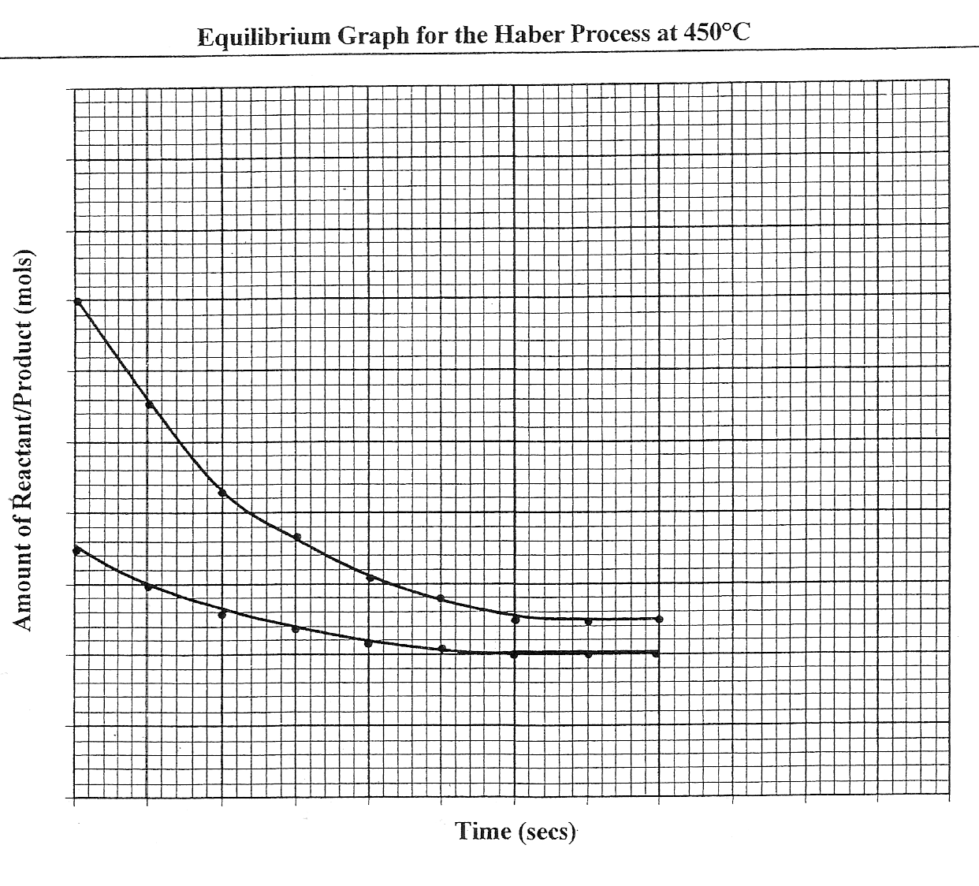

You are required to complete the graph by doing the following:

2.2.1 Insert the scale on the x and y axes. (2)

* + 1. Label the lines on the graph representing the amount of N2 and the

amount of H2. (2)

2.2.3 Using the data from the table, plot amount of product (NH3) versus time on the same axes. (4)

2.3 Use the completed graph to answer the following questions:

2.3.1 Give the **independent variable**. (1)

2.3.2 How long does it take for the reaction to reach equilibrium? Explain. (2)

2.3.3 Do any reactions occur during the time interval t = 70 s and t = 80 s.

Explain your answer. (3)

2.3.4 Compare the rate of the forward reaction at t = 50 s with the rate of the forward reaction at t =10 s. Explain briefly. (2)

2.3.5 Write down a balanced chemical equation for the formation of ammonia. (3)

2.3.6 Calculate the equilibrium constant (Kc) for the reaction at 4500C. (4)

When t = 80 s, the sealed container is heated causing a rapid rise in **temperature**. Equilibrium is re-established after an additional 20 s and maintained for a further 20 s.

2.4 Given that the forward reaction is exothermic, show the effect of an increase in temperature on the amounts of N2, H2 and NH3 for the time 80 s to 120 s by completing the lines on the graph for this period. (HINT: You will be given credit for showing the relative changes of amounts of N2, H2 and NH3.) (3)

**[31]**

**Question 3 (Hilton 2008 Q1)**

At room temperature and pressure, a flask was connected to a gas syringe. 60 cm3 of

0.05 mol.dm-3 dilute hydrochloric acid (HC*l*) was placed in the flask. 2g (an excess) of granules of a reactive metal were added, the flask was quickly stoppered and the readings of the volume of gas in the syringe were recorded at half minute time intervals.



The results of the experiment are shown below:

|  |  |
| --- | --- |
| **Time (minutes)** | **Volume of gas (cm3)** |
| **0** | **0** |
| **0.5** | **5** |
| **1** | **18** |
| **1.5** | **24** |
| **2** | **28** |
| **2.5** | **31** |
| **3** | **33** |
| **3.5** | **34** |
| **4** | **35** |
| **4.5** | **35.5** |
| **5** | **36** |
| **5.5** | **36** |

3.1 A colourless gas is produced in the reaction. What is the gas? (1)

3.2 Plot a graph of gas produced against time. (7)

3.3 How long did it take for 29 cm3 of gas to be produced? (1)

3.4 Look at how much gas was made during the first, second and third

minute of the reaction. What do these numbers indicate about how the rate

of reaction is changing with time? Use the collision theory to explain your

answer. (4)

3.5 Why is there an excess of granules used when reacting with the acid? (1)

3.6 The experiment was repeated using larger granules of excess metal.

The gas was still collected at room temperature and pressure.

1.7.1 On your graph **sketch** what you would expect to happen if larger

granules of excess metal was used. Label this **A.** (3)

1.7.2 Give reasons for your choice of sketch. (3)

3.7 The experiment was repeated again, but this time **only** the temperature was

increased. (The larger granules **were not** used.)

1.7.1 Sketch another line on your graph to show what you would expect

to happen if the temperature was increased. Label this **B**. (3)

1.7.2 Give reasons for your choice of sketch. (3)

3.8 The reaction of granules of the reactive metal is much slower with

0,05 mol.dm-3 ethanoic acid ( weak acid; partial ionisation) than 0.05 HC*l*

at room temperature. Account for the difference in the rate of reaction. (2)

**28 MARKS**

**Question 4 – (Hilton 2008 Q2)**

Read this extract carefully and then answer the questions that follow :

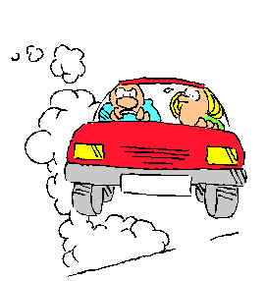**Pollution and Le Chatelier…**

As everyone knows, one of the most serious causes of pollution is the automobile.

All sorts of chemicals are present in the exhaust fumes leaving the engine and

various methods have been devised to control the amounts of these emissions.

One such method is the catalytic converter, which mixes air with the exhaust gases

and promotes oxidation of the unburned fuel and carbon monoxide

to carbon dioxide. They may also cause the decomposition of nitrogen monoxide into

elemental nitrogen and oxygen.

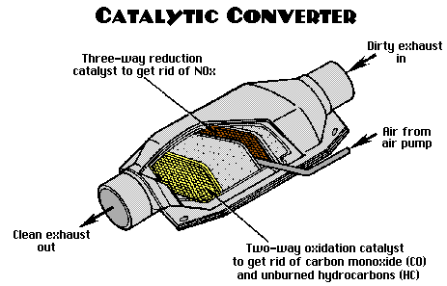

During the combustion of the gasoline the oxygen reacts with the **hydrocarbons** in the fuel to produce CO2 and H2O as shown in the following equation:

2C8H18(l) + 25O2(g) ⇌16CO2(g) + 18H2O(g)

When air is drawn into a car’s engine, both N2 gas and O2 are present. These gases react to form NO (g) according to the equation below:

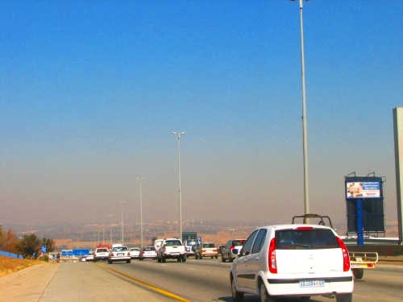N2(g) + O2(g) ⇌ 2NO(g) ∆H > 0

At room temperature the Kc for this reaction is 4,8 x 10-31

When the NO(g) leaves the exhaust it cools down and

remains as NO(g) in the atmosphere which then reacts

with O2(g) and forms brown NO2(g). This gas is responsible for

the brownish haze, commonly known as smog, which is often associated with severe pollution.

Adapted from “Chemistry: matter and its change” *fourth edition*, *Brady,*

*2004, pg 712. (****Trinity College June Exam****)*

4.1 Consider the **hydrocarbon** reaction:

2C8H18(l) + 25O2(g) ⇌ 16CO2(g) + 18H2O(g)

* + 1. Write down the expression to calculate the equlibrium constant

(Kc value) for this reaction? (2)

4.1.2 What does a Kc value tell you about an equation? (2)

4.2 The equilibrium constant for this reaction at two different temperatures is given in

the table below:

|  |  |
| --- | --- |
| **Temperature:** | **Equilibrium constant:** |
| 297K | 2,5 x 10-2 |
| 594K | 5 x 10-5 |

4.2.1 Is ∆H positive or negative for the forward reaction? Explain your reasoning using

the values from the above table. (3)

4.2.2 Do you think that the catalytic converter in the engine is helpful in preventing

pollution or not? Justify your answer with support from the text. (4)

4.3 Considering the **nitrogen** reaction:

N2(g) + O2(g) ⇌ 2NO(g) ∆H > 0 Kc = 4,8 x 10-31

4.3.1 What does the magnitude of the equilibrium constant for this reaction

indicate? (2)

4.3.2 State Le Chatelier’s Principle. (3)

4.3.3 The gases inside a car engine and exhaust reach extremely high

temperatures. What effect does this have on the above equilibrium and

thus on the production of NO(g)? Explain your answer in terms of

Le Chatelier’s Principle. (4)

* + 1. Would you consider it beneficial to the environment by running the

engine at a lower temperature in an attempt to reduce the amount of NO(g)

produced? Explain your answer fully. (3)

**23 MARKS**

Question 5 (Merrifield 2008 Q2)

Shanawaaz has recently moved from East London to Johannesburg and has not had his car re-tuned to high altitude conditions. As a result, the petrol in his car burns incompletely due to a lack of oxygen. This process produces, amongst other substances, carbon monoxide. The following balanced chemical equation represents the reaction during which carbon monoxide forms:

2C8H18 (*l*) + 17O2 (*g*) 16CO (g) + 18H2O (*g*) ΔH < 0

The reaction can be represented by the potential energy graph below.



5.1 Study the graph and explain whether it will be easier to form products from reactants or vice versa by comparing the activation energies of the forward and reverse reactions. (2)

LO3 AS2 level 2

5.2 Use the chemical equation above and give a reason why Shanawaaz’ car with its incorrectly tuned engine is a health hazard. (1) LO3 AS3 level 2

5.3 The manager of the car dealership, Max, recommends that Shanawaaz has a catalytic converter fitted to his car to help solve the problem. Max explains that part of the action of catalytic converters may be illustrated by the reactions represented by the equations below.

Petrol: 2C8H18 (l) + 25O2 (g) 16CO2 (g) + 18H2O (g) ……………… (i)

2CO (g) + O2 2CO2 (g)…………………………..…….…….. (ii)

5.3.1 What is the role of the catalytic converters in the car engine? (2) LO2 AS1 level 1

5.3.2 Why should people support legislation that makes catalytic converters a necessary component of exhaust systems of automobiles? (2) LO3 AS2 level 2 **[7]**

**Question 6 (Merrifield Q1 2008)**

Daniel investigated the relationship between the mass of a metal and the volume of the gas produced when the metal reacts with dilute hydrochloric acid. During the investigation he added the metal in amounts of up to 0,4g to a certain volume of acid in a container. After the complete reaction between the metal and the acid, he measured the volume of gas that forms after each addition of the metal.

6.1 State a possible hypothesis for this investigation. (2) LO1 AS1 level 3

6.2 Daniel recorded his data obtained in the table shown below after conducting the investigation.

|  |  |
| --- | --- |
| Mass of metal (g) | Volume of gas (cm3) |
| 0,1 | 45 |
| 0,3 | 130,0 |
| 0,6 | 250,0 |
| 0,8 | 315,0 |
| 1,0 | 350,0 |
| 1,2 | 375,0 |
| 1,6 | 380,0 |
| 2,0 | 380,0 |
| 2,4 | 380,0 |

Plot a graph of his data. (6)

6.3 Explain the shape of the graph. (4) LO2 AS2 level 3

6.4 Name TWO variables that must be controlled during this investigation. (2) LO1 AS1 level 2

6.5 Use the graph to predict the volume of gas that will be produced when 0, 4 g of the metal reacts with the acid. (2) LO1 AS3 level 4

[16]

**Question 7 (St Andrew’s Girls Q9 2008)**

Ammonia is a very important chemical.

|  |  |
| --- | --- |
| **SUBSTANCES MADE FROM AMMONIA** | **PERCENTAGE (%) OF AMMONIA USED** |
| fertilizers | 75 |
| nitric acid | x |
| nylon | 5 |
| others | 10 |

7.1 What is the value of x – the percentage of ammonia used to make nitric acid? (1)

7.2 What is the name of the industrial process used to produce ammonia? (1)

The production of ammonia is a reversible process as shown by the following equation:

N2(g) + 3H2(g)  2NH3(g) + heat

7.3 Is the forward reaction exothermic or endothermic? (1)

7.4 The table shows the percentage yield of ammonia at different temperatures and pressures.

|  |  |  |
| --- | --- | --- |
| **PRESSURE (ATMOSPHERES)** | **PERCENTAGE (%) YIELD OF AMMONIA AT 350°C** | **PERCENTAGE (%) YIELD OF AMMONIA AT 500°C** |
| 50 | 25 | 5 |
| 100 | 37 | 9 |
| 200 | 52 | 15 |
| 300 | 63 | 20 |
| 400 | 70 | 23 |
| 500 | 74 | 25 |

7.4.1 Use the data in the table to draw two graphs on the grid on your answer sheet. Draw a graph of best fit for each temperature and label each graph with its temperature. (6)

7.4.2 Use your graph to find the conditions needed to give a yield of 30% ammonia. (1)

7.4.3 On the grid, sketch the graph you would expect for a temperature of 450oC. (1)

**Question 8 (St Andrew’s Girls 2008 Q8)**

Gas A decomposes slowly in a closed container to form gases B and C. An equilibrium is established as shown by the equation:

A(g)  B(g) + C(g) *H* is positive

8.1 What does the symbol “” mean? (1)

8.2 In terms of the behaviour of particles, state two criteria that must be fulfilled before molecules of A can react to form B and C. (2)

8.3 List 4 ways in which the rate of this reaction may be increased. (4)

The graphs below show how, starting from A alone, the concentration of A varies with time at temperatures of 300K (27oC) and 320K (47oC) for the reversible reaction above at a constant pressure.



8.4 Suggest why, as shown on the graphs, the concentration of A remains constant after a time. (1)

8.5 Explain why, at 320K, the concentration of A falls to a lower value compared with the reaction at 300K. (2)

8.6 Would you expect the concentration of A to increase, decrease or remain the same if the pressure of the container is increased while the temperature is maintained at 300K? Explain your answer. (3)

8.7 The container is now raised to a temperature of 350K and the pressure is maintained at 1 atm. An equilibrium is established and it is found that the container contains 3 moles of gas A, 3 moles of gas B and 3 moles of gas C.

8.7.1 Write a mass action expression for this reaction. (2)

8.7.2 Determine the volume of the container if the kc for this reaction is 12. (3)

**Question 9**

**An Investigation to the Rate of a Reaction**

Susan investigates the following reaction in order to understand how **surface area** affects the rate of a reaction:

**CaCO3(s) + HC**ℓ**(aq) → CaC**ℓ**2(aq) + H2O(**ℓ**) + CO2(g)**

* 1. Explain in terms of the collision theory how a change in surface area of the reactants would affect the rate of **this** reaction. (4)
  2. Design an experimental method that Susan can follow for her investigation. Use the following two headings:

**a) LABELLED DIAGRAM of experimental set-up:** (4)

**b) The independent variable(s):**

**The dependent variable(s):** (2)

* 1. Susan needs to measure one of the variables over time in order for her to determine the effect of surface area on the rate of the reaction. Draw a rough, **qualitative** sketch graph of what you expect the outcome of her investigation to be. Clearly label the axes of the graph. (4)
  2. What other factor(s), which could affect the rate of this reaction, does Susan have to control? (4)

**[18]**

========================================================================

**Question 10 - Rate of Reactions**

The aim of the following activity was to investigate the effect of changing reaction conditions on the reaction speed.

A food dye solution was made up, consisting of 1 drop of double concentrated food dye in one litre of water. 100 ml of this food dye solution was poured into a 250 ml beaker **A**, and 100 ml of this food dye solution was poured into a 250 ml beaker **B**.

**Experiment 1**: 100 ml of bleach was added to the food dye solution in beaker **A** and the concentration of the food dye was measured every minute with a spectrophotometer.

**Experiment 2**: A 100 ml mixture of 50 ml bleach and 50 ml water was added to the food dye solution in beaker **B**. The concentration of the food dye was measured every 30 seconds with a spectrophotometer. Table 1 shows the results of Experiments 1 and 2.

***Table 1: Dye concentration over time with various bleach strengths***

|  |  |  |
| --- | --- | --- |
| **Time**  **(min)** | **Experiment 1 (adding regular bleach)** | **Experiment 2: (Adding a 1:1 bleach-water mixture)** |
| *Dye Concentration (mol.dm-3)* | |
| **0,0** | 2,50 | 2,50 |
| **1,0** | 0,75 | 1,23 |
| **2,0** | 0,40 | 0,70 |
| **3,0** | 0,25 | 0,47 |
| **4,0** | 0,15 | 0,30 |

10.1.1 Draw a graph of the dye concentration over time for both Experiments on the same

axes. (7)

10.1.2 What can you conclude from this graph ? (1)

* 1. .1 Define the concept “rate of reaction”. (2)

10.2.2 Use the graph to determine the average rate of reaction during the:

5.2.2.1  **first** **two** minutes of **Experiment 1** and, (2)

* + - 1. **last two** minutes of **Experiment 1**. (1)

10.3 The reaction rate is **NOT** constant as the gradient of the curve is changing.

Give one possible explanation for this observation. (3)

**[16]**

========================================================================

**Question 11 - Chemical Change**

Consider the reaction between zinc metal and hydrochloric acid.

* 1. Using chemical symbols, rewrite and balance the reaction equation. (2)
  2. Give three ways, other than increasing the temperature, to increase the initial rate

of the reaction. (3)

* 1. Explain, using molecular theory, how increasing the temperature of the acid solution increases the rate of this reaction. (3)

**[8]**

========================================================================

**Question 12 - Chemical Equilibrium**

12.1 Which of the following reactions will **not** form an equilibrium situation? Write down the letter **A**, **B**, **C** or **D** only.

**A** H2O(ℓ)  H2O(g) (in a sealed bottle)

**B** CaCO3(s) + H2SO4(aq)  CaSO4(s) + CO2(g) + H2O(ℓ) (in a beaker)

**C** CaSO4(s) Ca2+(aq) + SO42-(aq) (in a beaker)

**D** SO3(g)  SO2(g) + O2(g) (in a sealed vessel) (3)

* 1. Explain carefully what is meant by ‘dynamic chemical equilibrium’. (2)
  2. For the reaction: CO(g) + H2O(g) H2(g) + CO2(g) ΔH <0

12.3.1 Write down the equilibrium constant expression (Kc) for this reaction. (2)

12.3.2 You are told that at 800 K, the **equilibrium constant** for this reaction

is **5,1**. Interpret this value. (2)

* 1. What would happen to the concentration of the CO if:

12.4.1 the **temperature** of the reaction was increased?

12.4.2 the **amount of H2O** was increased?

12.4.3 the **pressure** of the system was increased?

12.4.4 the **amount of product** was increased?

12.4.5 a **catalyst** was added? (5)

* 1. Which of these changes would affect the value of the Kc? (2)

**[16]**